EXP 4 Cyclic Redundancy Check/Checksum
Date: 17th August 2026/24th August 2026

AIM: Implementation of error detection methods- CRC and Checksum

Theory:
Points to be included in theory are:

- Explain the working of CRC at sender and receiver side using an example
- Advantages and disadvantages of CRC
- Explain the calculation of checksum and its purpose at the sender and receiver side
Students note this experiment has 2 parts:
4.1 –Implementation of CRC

What are checksum Algorithms?
Checksum algorithms are used in computing to verify the integrity of data transmitted over a network or stored in a file. These algorithms generate a fixed-size hash value (checksum) from the data, which can be used to detect errors or tampering. If the data is modified in transit or storage, the checksum will typically change, indicating that the data has been altered.

Role of checksum algorithms in data integrity
Checksum algorithms play a crucial role in ensuring data integrity, particularly in scenarios where data is transmitted over networks or stored in files. Here's how they contribute to maintaining data integrity:
- Error Detection: Checksum algorithms generate a unique hash value for a given set of data. By comparing this hash value before and after transmission or storage, it's possible to detect errors such as data corruption, tampering, or transmission errors. If the hash values do not match, it indicates that the data has been altered in some way.
- Data Verification: Checksums can be used to verify that data has been received or stored correctly. By recalculating the checksum on the received data and comparing it to the transmitted checksum, the recipient can ensure that the data has not been altered during transmission.
- Data Integrity Assurance: Checksums provide a way to verify the integrity of data without needing to compare the entire dataset. This is particularly useful for large files or data streams, where verifying each individual bit would be impractical.
- Efficiency: Checksum algorithms are computationally efficient, allowing for quick verification of data integrity without significant overhead.

Common checksum algorithms include:
- MD5 (Message Digest Algorithm 5): Produces a 128-bit hash value. While still widely used, it's considered insecure for cryptographic purposes due to vulnerabilities that allow collisions (different inputs producing the same hash).
- SHA-1 (Secure Hash Algorithm 1): Produces a 160-bit hash value. Like MD5, it's no longer considered secure for cryptographic purposes due to vulnerabilities.
- SHA-256, SHA-384, and SHA-512: Part of the SHA-2 family, these algorithms produce hash values of 256, 384, and 512 bits respectively. They are widely used and more secure than MD5 and SHA-1.
- CRC (Cyclic Redundancy Check): A family of algorithms that produce a checksum, often used in network communications and storage systems. CRC is more efficient for error detection but less secure for cryptographic purposes.

Reference to CRC on the web:
Cyclic Redundancy Check and Modulo-2 Division - GeeksforGeeks
4.2 –Implementation of Checksum
A checksum is an error detection method used by upper-layer protocols. It is considered to be more reliable than Longitudinal Redundancy Check (LRC), Vertical Redundancy Check (VRC), and Cyclic Redundancy Check (CRC).
- This method uses a Checksum Generator on the sender side.
- A Checksum Checker is used on the receiver side.
- The checksum is a unique number generated from the data to verify its integrity.
- If the two checksums match, the data is likely error-free.

How Checksum work?
Checksum works by summing all data segments using 1’s complement arithmetic, taking the complement of the result, appending it to the data, and verifying at the receiver by checking if the final complemented sum (including checksum) equals zero.
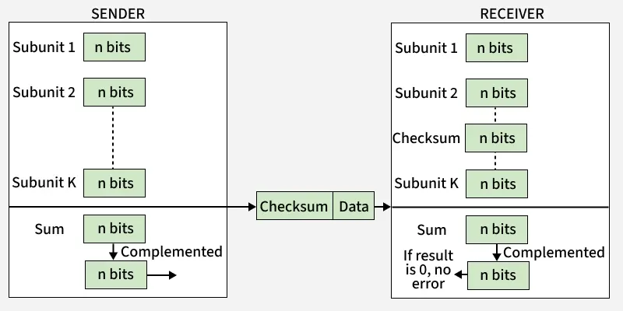

Sender Side:
- Data Division: The data is divided into equal-sized subunits of n bits (commonly 16 bits).
- Addition Using 1’s Complement: All the subunits are added together using 1’s complement arithmetic. If a carry is generated beyond the most significant bit, it is wrapped around and added to the least significant bit.
- Checksum Calculation: The final sum is then complemented (1’s complement). This result is known as the checksum.
- Transmission: The original data along with the checksum is transmitted to the receiver as a single unit.

Receiver Side:
- Receiving Data and Checksum: The receiver gets the combined block of original data and checksum.
- Data Division: The received block is divided into subunits of n bits, same as at the sender side.
- Addition Using 1’s Complement: All subunits, including the checksum, are added together using 1’s complement addition with end-around carry.
- Final Complement and Validation: The result of the sum is complemented. If the final result is all zeros, the data is considered to be error-free.
- Error Detection: If the result is non-zero, it indicates that an error has occurred during transmission, and the receiver rejects the data.

Example 1 - If the data unit to be transmitted is 10101001 00111001, the following procedure is used at Sender site and Receiver site.
Sender Site:
10101001 subunit 1
00111001 subunit 2
11100010 sum (using 1s complement)
00011101 checksum (complement of sum)
Data transmitted to Receiver is:
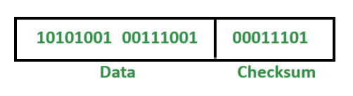

Receiver Site:
10101001 subunit 1
00111001 subunit 2
00011101 checksum
11111111 sum
00000000 sum's complement

Result is zero, it means no error.

Conclusion:

